Introduction

Risk management is a critical process involving continuous risk identification, risk assessment and risk control. The process is applicable throughout the life cycle of the project. Risk Management ensures that risk are well understood, analyzed and mitigated and when goes out of control, escalated to senior management / customer in a timely manner.

Scope
This procedure is applicable to projects of all types.

Process Practitioner
PM, SM

Objective
- To identify, analyze and prioritize risks.
- To track and manage risks continuously
- To identify mitigation plans for risks with higher probability and impact and execute in a timely manner

Entry

Criteria
Project start
Periodic review as part of project monitoring
As response to the following events:
- Risk occurrence
- Any event that has an impact on the project schedule, efforts and quality

Input
Risk Database
Proposal
RML

Flow Chart

START
END
RML
Risk Assessment
Risk database
Proposal
Inputs from SM

Risk monitoring
Execute risk mitigation

Risk resolution

Project closure
Risk occurs?
Mitiation required?
Y
N
Y
N
Y
End of Projct?
N

Tasks

Sub Process | Responsibility

Risk assessment
- Identify risks – Refer checklist for software risk identification in projects  - Study assumptions to identify risks in the project  - Analyze risks for probability, impact and calculate risk Index  - Classify risks based on phase it is likely to occur and Type of risk.  - Prioritize risks and identify type of response and type of action plan  - Identify anticipated impact on the project  - Prepare action plan for mitigation of risks  - Prepare RML  - Define risk tracking frequency in PMP | PM
- Give inputs to identify risks and prepare action plan  - Verify RML | SM

Risk monitoring
- Track risks based on periodicity / event  - Discuss relevant risks with PL & other team members in status review meetings  - Identify new risks, analyze and formulate action plan  - Assess risks and update plans in RML for changed risk perceptions  - Execute Action plan as planned  - Communicate high impact risks to SM and relevant risks to Customer | PM
- Give inputs prepare action plan for newly identified risks  - Verify RML | SM

Execute risk mitigation
- Plan and schedule for implementing action plans of “Preventive” response type  - Execute Action plans and update status in RML  - Assess the effectiveness of Action plans | PM
- Review and authorize execute of Action plan | SM

Risk resolution
- Identify the realized risk  - Assess impact of realized risk  - If contingency action plan not available (unanticipated risks), devise action plan immediately  - Execute action plans to minimize the impact  - Absorb risk if mitigation / corrective action is not possible / feasible  - Identify the actual impact on the project and update along with actual action taken for materialized risks. | PM

Project closure
- Send updated RML to SQA for updating in Risk database | PM

Guidelines

- Focus more on risks with higher risk index
- Plan and execute action plan for risks with high priority (Higher risk index) which mitigates impact of risk
- For other risks, execute action plan when the risk occurs to minimize the impact
- Few risks may be worth absorbing as the cost of mitigation might be higher
- Use the following to identify, plan and mitigate project risks
- Utilize the experience of project team
- Consult experts
- Consult SM for identifying and arriving at mitigation
- Consult SM before taking any major corrective action

Risk management in projects - Excerpt from APMBOK, UK

Risk Management covers the process of identification, assessment, allocation, and management of all project risks. Risks are present in all projects, whatever their size or complexity and whatever industry or business sector. Risks exist as a consequence of uncertainty. In project management terms, risks are those factors that may cause a failure to meet the project’s objectives.

Project risk management recognises a formal approach to the process as opposed to an intuitive approach. Risks, once identified, assessed and allocated should be managed in order to minimise or completely mitigate their effect on a project. This may be achieved by developing either immediate or contingency responses to the identified risks. Such responses may remove, reduce, avoid, transfer, or accept the risks or lead to the abandonment of the project.

While risks are, according to the dictionary, associated with the possibility of failure, they may also be associated with opportunities. The usual definition of a risk in project management is that the risk is the product of the probability of an event occurring times its impact if it did. Risk management should balance the upside opportunities with downside risks, doing so in an open, clear and formal manner.

Risk Management Cycle

Identify risks – Risk management cycle starts with identification of risks.

Analyze – Identified risks are analyzed thoroughly and likely Phase of occurrence, Risk type and Anticipated impact are determines. Also Probability and Impact are determined based on past experience and SM guidance. This helps us to plan for risk management.

Plan – Based on the analysis, risks are prioritized and Response type (Preventive or Contingency), Action plans are determined.

Track – Risks are tracked continuously and latest status is updated. New risks are also identified.

Control – Action plans are executed to control risks either before occurrence (Preventive) or after occurrence (Contingency) to ensure that impact of risks are minimum as planned. Effectiveness of risk plan is also measured and control strategies are fine-tuned.

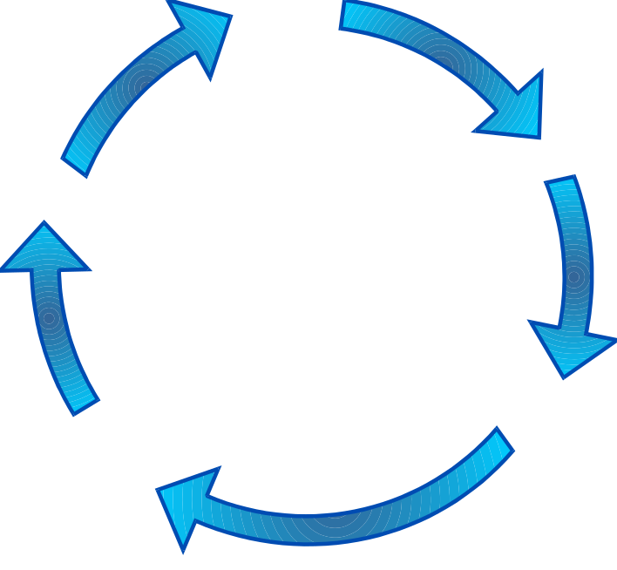
Plan
Control

rack

Analyze

Mitigation required?

Risk occurs?

Mitigation required?

Risk occurs?

Mitigation required?

Risk occurs?

Mitigation required?

Risk occurs?

Risk Management Cyce

Identify

This cycle continues till the project is completed and final acceptance is received.

Checklists / Standards

Checklist for Software Risk Identification in projects

Sl. No. | Requirements
 | Stability/Completeness [assessed by evaluating the amount of information in the requirements]
1 | Are the requirements changing or yet to be determined? | Consider the risk if requirements are being added, changed or are undetermined.
2 | Does the Project have unwritten requirements/expectations? | Consider the risks if some project requirements were given to you verbally.
 | Clarity [assessed by evaluating your comprehension of the requirements]
3 | Are you able to understand the requirements as written? | Consider the risk if key requirements are vaguely stated (ambiguous).
 | Feasibility [assessed by evaluating the possible difficulties that might arise later in the project]
4 | Are there any requirements that are technically difficult to implement? | Consider the risk if you aren't sure how a requirement could be implemented in the development language.
 | Tracking [assessed by evaluating the ability to keep requirements visible during the project]
5 | Do you have a plan to track the requirements throughout the design, coding and testing phases? | Consider the risk if requirements fall out of the process and are not handled in the correct phase.
 | Design
 | Functionality [assessed by evaluating the feature set of and capabilities of the product]
6 | Are there any specified algorithms that may not (or only partially) satisfy the requirements? | Consider the risk that the algorithms may be wrong, incomplete, or too complex.
 | Difficulty [assessed by evaluating the effort involved in producing the design]
7 | Does any of the design depend on unrealistic or optimistic assumptions? | Consider the risk if requirements were too optimistic regarding design.
8 | Are there any requirements or functions that are difficult to design? | Consider, for example, the risk that a complex tree search may require more effort to design.
 | Interfaces [assessed by evaluating the connections between components, or to the outside world]
9 | Are the internal and external interfaces well defined? | Consider the risk of complex or numerous connections between components or systems.
 | Performance and Quality [assessed by evaluating the functionality and quality of the product]
10 | Are there any problems with the expected performance, or quality, of the design? | Consider the risk of inadequate response or turnaround time, or lack of functionality.
 | Testability [assessed by evaluating the effort required to sufficiently test the product]
11 | Is the software going to be easy to test? | Consider the risks of high complexity and what that may do in testing the product.
 | Hardware Constraints [assessed by evaluating the hardware of the target or development platform]
12 | Does the development or target hardware limit your ability to meet any requirements? | Consider the risk of limitations on hardware speed, size, availability and functionality.
 | Software Reuse [assessed by evaluating the extent to which software is reused in the product]
13 | Does re-used or re-engineered software exist? | Consider the risk that re-used software that needs modification may cause more problems than designing original software.
 | Code and Unit Test
 | Feasibility [assessed by evaluating the relative ease necessary to perform code and test]
14 | Are any parts of the product implementation not completely defined by the design specification? | Consider the risk of not being able to track the requirements to the design, and then to the code.
15 | Are the selected algorithms and designs easy to implement? | Consider the risk of overly complex components, or components with poor internal interfaces.
 | Testing
16 | Is there sufficient time to perform the entire unit testing that you specified? | Consider the risk of not having enough time in the schedule for this activity.
17 | Will compromises be made regarding unit testing if there are schedule problems? | Consider who will compromise, and on what components. Consider what may be missed.
 | Coding/Implementation
18 | Are the design specifications in sufficient detail to write the code? | Consider the risk if the design is too high level.
19 | Is the design changing while coding is being done? | Consider the scope of the changes; large changes could cause wasted coding effort.
20 | Is the language suitable for producing the software of this program? | Consider the risk of using a relational language to crunch numbers (extreme case).
21 | Does your team have enough experience with the development language, platform or tools? | Consider the risk if your team is not well represented in these areas.
22 | Is there are risk that a key component or module will not be complete or on schedule? | Consider the risk, for example, that a parsing component is incomplete in the late coding phase.
23 | Are you comfortable with your team’s estimate on coding time and effort? | Consider the risk if you grossly underestimated the effort required of you.
24 | Do you have a plan for configuration management of the code? | Consider the risk if there is no revision control or there is uncontrolled code modification.
 | Integration and Test
 | Environment [assessed by evaluating the hardware and software support facilities and test cases]
25 | Will there be sufficient hardware to do adequate integration and testing? | Consider the risk of not being able to get computer time
26 | Is their any problem with developing realistic scenarios and test data to demonstrate any requirements? | Consider the risk of meeting the schedule, and testing coverage.
 | Product [assessed by evaluating the integration and testing of groups of components]
27 | Have acceptance criteria been agreed to for all requirements? | Consider the risk of not knowing exactly what is expected.
28 | Has sufficient product integration been specified, and has adequate time been allocated for it? | Consider the risk of meeting the schedule and getting sufficient testing Coverage.
 | System [assessed by evaluating the integration between the product and target hardware]
29 | Has sufficient system integration and system integration time been specified? | Consider the risk of meeting the schedule and getting sufficient testing coverage.
 | Maintainability [assessed by evaluating the effort required to locate and fix errors]
30 | Is the product design and documentation adequate for future use? | Consider the risk if this is a requirement.
 | Specifications
31 | Are the test specifications adequate to fully test the system? | Consider the risk of poorly written requirements or specifications.
 | Communication, Team Compatibility and Motivation
 | Communication [assessed by evaluating the ability of the team to exchange information]
32 | Is there a lack of good communication amongst your team? | Consider the risk if the team is not sharing the exchanging the information.
33 | Is there a lack of good communication with your PL/Coordinator about the project? | Consider the risk to the quality of your work if you have incomplete information.
 | Compatibility of Team [assessed by evaluating the ability of the team to work productively]
34 | Is your team familiar to you; have you worked together on a team project before? | Consider the risk if the team is not comfortable working together, or has not done so before.
35 | Are tasks delegated in a fair manner amongst your team? | Consider the risk if your team is not in agreement.
 | Motivation of Team [assessed by evaluating the goals of the team]
36 | Is your team motivated to create a good product? | Consider the risk to the project, if grades are the sole motivation.

Associated Templates, tools

Templates |  | Tools
RML |  | Risk database
 |  | MPP

Control Mechanism

- SMR to be conducted to review the RML and when major risks are identified. SM’s guidance to be taken to workout action plan for major risks and decide the risks to be mitigated
- Risks to be escalated to the concerned when the resolution could not be achieved within reasonable period / executed action plan fails to produce results
- SQA / QL to check RML and assess whether all major risks have been identified and assessed properly. QL also to assess the effectiveness of proposed action plans

Verification

Item | Activity | Who
PMP | Verify | SM
RML | Verify | SM

Exit

Criteria
- Execution of action plan to mitigate major risks
- Execution of action plan for un-mitigated risks when the risk arises
- Acceptance of risk
- End of project

Output
- RML
- Updated schedule for execution of action plan for risk response
- Updated Risk database

Tailoring

NA

References

- Risk Radar tool
- PMBOK (Project management body of knowledge) of PMI (Project management institute, USA)

